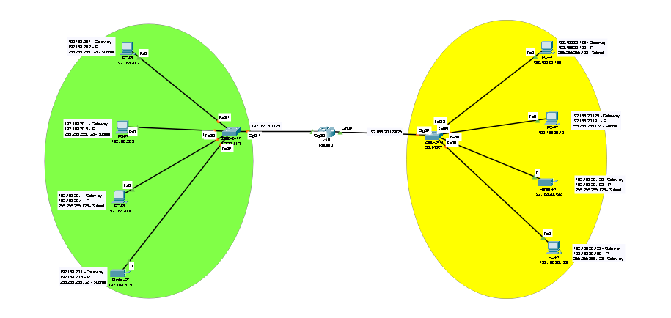

**Design Network in CISCO Packet tracer to connect ACCOUNTS and DELIVERY Departments through the following:**

1. **Each department should contain at least 4PCs.**
2. **Appropriate number switches and routers should be used in the network.**
3. **Using the given network address 192.168.20.0, all interface should be configured with appropriate IP addresses, subnet mask and gateways.**
4. **All devices in the should be connected using appropriate cables.**
5. **Test the connectivity between ACCOUNTS and DELIVERY Department -PCs in DELIVERY department should be able to ping the PCs in ACCOUNT department.**

**Technologies Implemented**

1. Creating a Simple Network using a Router and Access Layer Switch.

Router Model 2911

Access Layer Switch Model 2960-24TT

1. Connecting Networking devices with Correct cabling.

Copper Stright Wire

1. Connecting two Networks using a Router.
2. Subnetting and IP Addressing.

255.255.255.128 == Subnet Mask

IP Range = 192.168.20.1 – 192.168.20.126

IP Range = 192.168.20.129 – 192.168.20.225

1. Assigning IP Addresses to Router's interfaces.

**Router Configurations**

Router>enable

Router#configure

Router(config)#

Router(config)#interface gigabitEthernet 0/1

Router(config-if)#ip address 192.168.20.1 255.255.255.128

Router(config-if)#no shutdown

Router(config-if)#exit

Router(config)#

Router(config)#interface gigabitEthernet 0/1

Router(config-if)#ip address 192.168.20.129 255.255.255.128

Router(config-if)#no shutdown

Router(config-if)#exit

Router(config)#exit

Router#wr

Router# show running-config

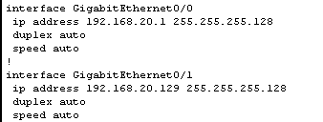

1. Static IP Address allocation to Host Devices.

**ACCOUNT DEPARTMENT**

Router 0/0 = 192.168.20.1 255.255.255.128

Devices Like PC and printer

192.168.20.1 - Gateway

192.168.20.2 -126 - IP Range

255.255.255.128 - Subnet

**DELIVERY DEPARTMENT**

Router 0/1 = 192.168.20.129 255.255.255.128

Devices Like PC and printer

192.168.20.1 - Gateway

192.168.20.130 - 255 - IP Range

255.255.255.128 - Subnet

1. Test and Verifying Network Communication.

**Subnetting**

Network Address = 192.168.40.0

No.of Subnets = 2

2^n = no. of subnets = = = = = 2^n = 2

N = 1

128 64 32 16 8 4 2 1

7 6 5 4 3 2 1 0

255.255.255.255

11111111.11111111.11111111.10000000

255.255.255.128 == Subnet Mask

1st Subnet

Subnet Mask = 255.255.255.255.128

Network Id = 192.168.20.0

IP Range = 192.168.20.1 – 192.168.20.126

Broadcast ID = 192.168.20.127

2nd Subnet

Subnet Mask = 255.255.255.255.128

Network Id = 192.168.20.128

IP Range = 192.168.20.129 – 192.168.20.225

Broadcast ID = 192.168.20.256